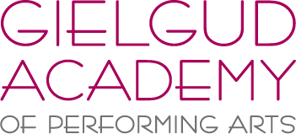

SUMMER SCHOOL 2016

Tuesday 2nd August – Friday 5th August 2016, 10am – 4pm, £175

1. Personal Information -

Students Name:
Students Age
Parent/Guardians Name:
Home Address:

Email:
Contact Number(s):
Medical considerations :

2. Current standard (please include organization – ISTD/RAD etc) and length of time studying –

Ballet:
Modern:
Tap:
Jazz:
Contemporary:
Drama
Another skills studied:

3. Last exams taken (please include Genre, Grade, Year and Result) –

Please email your booking form to admin@gielgudacademy.co.uk.
Once confirmation of a place has been given, a £50 non-refundable deposit will need to be paid. The remaining £125 will be payable by Monday 1st August 2015.

The Gielgud Academy Summer School will be held at
The Hub, Harlands Road, Haywards Heath, West Sussex, RH16 1LT.

Please call 01444 451977 with further enquiries.

