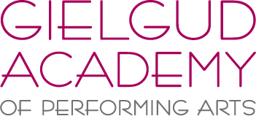

SUMMER SCHOOL 2018

Monday 30th July – Friday 3rd August 2018, 10am – 4pm

Monday 6th August – Friday 10th August 2018, 10am – 4pm

Weekly Rate: £150 - Daily Rate: £35

Minimum age: 9 (Grade 2) Maximum age: 18 (Inter/Adv/Professional)

1. Personal Information –
Students Name:
Students Age
Parent/Guardians Name:
Home Address:
Email:
Contact Number(s):
Medical considerations:

2. Current standard (please include organization – ISTD/RAD etc) and length of time studying –
Ballet:
Modern:
Tap:
Jazz:
Contemporary:
Drama:
Another skills studied:

3. Current Dance School –

Please email your booking form to admin@gielgudacademy.co.uk
Once confirmation of a place has been given, the £150 (or Daily Rate) will need to be paid

The Gielgud Academy Summer School will be held at –
Great Walstead School, East Mascalls Lane, Lindfield, West Sussex, RH16 2QL

Please call 01444 848656 with further enquiries

