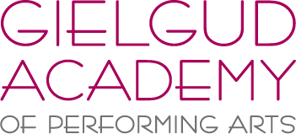

SUMMER SCHOOL 2021

Monday 16th – Thursday 19th August, 10am – 3pm

Weekly Rate: £150 (for 4 days)
Daily Rate: £40

Minimum age: 9 (Grade 2) Maximum age: 18 (Inter/Adv/Professional)

1. Personal Information –
Students Name:
Students Age
Parent/Guardians Name:
Home Address:
Email:
Contact Number(s):
Medical considerations:

2. Current level/standard (please include organization – ISTD/RAD etc) and length of time studying –
Ballet:
Modern:
Tap:
Jazz:
Contemporary:
Drama:
Other skills studied:

3. Current School –

Please email your booking form to admin@gielgudacademy.co.uk

Once confirmation of a place has been given, a deposit of £25 will need to be paid.
The balance will be payable 14 days before the summer school commences.

Should we have to cancel the summer school due to a change in the current
Government Covid guidelines or a lockdown, then a full refund will be given.

The Gielgud Academy Summer School will be held at –
The Hub, Haywards Heath College, Harlands Road, Haywards Heath, RH16 1LT

Please email or call 01444 812111 with further enquiries

